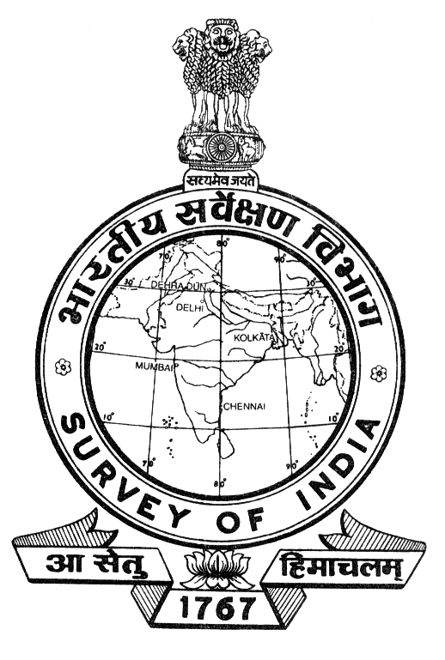

SURVEY OF INDIA

vle ,oa ukxkyS.M

ASSAM & NAGALAND
Hkw&LFkkfud vkWdM+k dsUnz
GEO-SPATIAL DATA CENTRE
x.ks'kxqM+h pkjhvkyh] fnliqj
GANESHGURI CHARIALI, DISPUR
th- ,l- jksM] xqokgkVh & 781006

G.S. ROAD, GUWAHATI- 781006

 0361-2234370
QSDl 0361- 2261725
bZ&esy angdcguw-asm@nic.in

No. 46 / 15-L-2 Dated 09 -01-2013

T E N D E R N O T I C E

SUB: DISPOSAL OF UNSERVICEABLE AND OBSOLETE PHOTOGRAMMETRIC INSTRUMENTS

The office of the Additional Surveyor General, Assam & Nagaland GDC invites sealed tenders for auction sale of unserviceable and obsolete Photogrammetric Instruments which are available in the office premises of Officer In-Charge, Shillong Wing, Assam & Nagaland GDC, Post Box No. 39, Bonnie Brae Estate, Malki, Shillong- 793001, Meghalaya in “As is where is basis” conditions and may be inspected on any Govt. working day between 1100 hours to 1600 hours except 1300 hours to 1400hours from 11.02.2013 to 27.03.2013.

The Details of the Instruments are given in Annexure-II

Last date of submission of Sealed Tenders is 9th April 2013 at 1600 hrs.
Opening date of Tenders is 10th April 2013 at 1400 hrs.

Terms and Conditions: -

1. Earnest Money Deposit (EMD): EMD of Rs. 30,000/- (Rupees Thirty thousand only) should be submitted along with the Tenders in the shape of Demand Draft in favour of E & A.O., Meghalaya & Arunachal Pradesh GDC, Survey of India, payable at Shillong failing which tenders will not be accepted.
2. Earnest Money will be returned to the unsuccessful tenderer and no interest will be paid for the same.
3. Tender should be submitted under sealed cover only at our Shillong Office as per the given address: -
Officer In-Charge
Shillong Wing
Assam & Nagaland GDC
Post Box No. 39
Bonnie Brae Estate, Malki
Shillong- 793001, Meghalaya
4. Tender should be addressed to Officer In-Charge, Shillong Wing, Assam & Nagaland GDC
Post Box No. 39, Bonnie Brae Estate, Malki, Shillong-793001, Meghalaya and NOT BY NAME OR NOT TO ANY OTHER ADDRESSEE and can be dropped in the office Tender Box at Shillong Office.
5. Tenders should reach within the specific time and date to the addressee by 1600 hrs on or before 09/04/2013. The tenders will be opened on 10/04/2013 at 1400 hrs. The envelop containing tender must be inscribed with “Tender FOR UNSERVICEABLE STORES OF PHOTOGRAMMETRIC INSTRUMENTS.”
6. The reserved Price (minimum price) for lifting the instrument has been kept as Rs. 1,70,000 (Rupees One Lakh Seventy Thousand only).
7. The tender shall remain valid for 90 days from the opening date of tender.
8. If any amount is payable on account of VAT / Sale Tax or any other taxes pertaining to sale/ transaction, the buyer shall be bound to pay such amount in addition to the quoted rate. All such taxes shall be deposited directly with the concerned authority and challans to be submitted to this office at the time of delivery by the successful tenderer.
9. Tenderer, if so desires may be present on the date and time of opening tenders. They may enquire over telephone (0364-2223583) before their arrival for tender opening.
10. The Additional Surveyor General Assam & Nagaland GDC, Survey of India, Ganeshguri Chariali, Dispur, G.S. Road, Guwahati-4, Assam reserves the right to reject or accept any quotation without assigning any reasons thereof.
11. NO PRICE VARIATION IS ACCEPTABLE DURING THE VALIDITY PERIOD.
12. Only the highest offer will be accepted.
13. Successful tenderer will have to deposit the full amount of unserviceable stores plus copy of applicable taxes within 48 hours from the date of acceptance at Shillong office.
14. The bidder may inspect the unserviceable stores on the days between (11.02.2013 to 27.03.2013) 1100 hrs to 1600 hrs (except 1300 hours to 1400hrs) to satisfy themselves about the items they are bidding in the following Address: Officer In-Charge, Shillong Wing, Assam & Nagaland GDC, Post Box No. 39, Bonnie Brae Estate, Malki, Survey of India, Shillong-793001.
15.The Unserviceable stores shall be sold to the highest bidder; VAT and other taxes will be extra as applicable.
16. Unserviceable stores once disposed to the successful bidder shall NOT be taken back by SOI (Survey of India) under any circumstances.
17. The successful bidder shall be required to lift unserviceable stores from the Survey of India, Shillong site premises to his site within 10 days (within 19.04.2013 1530hrs) during working hours after payment of the bid amount for which the Demand Draft should be made in favour of E & AO, Meghalaya & Arunachal Pradesh GDC, Shillong. On the failure to do so, SOI shall have full right to forefeit the Earnest Money Deposit (EMD) of the bidder. EMD will be refunded after lifting the items from office premises. To lift the materials on holiday will be not be permitted under any circumstances.
18. Tender received after the stipulated date and time shall not be considered due to any reason whatsoever including postal delays etc.
19. The financial bid should be quoted both in figures and words along with Sales TAX/VAT, if any. Any overwriting or erasing in the figures shall not be considered for acceptance of the rates offered by the tenderer. Sales Tax/VAT etc. shall be borne by the tenderer.
20. Each page of the tender document should be signed by the bidder(s). Incomplete and unsigned tenders are liable to be rejected. Rate is to be quoted in Tender Form enclosed as Annexure I.
21. The highest bidder shall be chosen based on the amount quoted and filling the tender conditions.
22. No assistance whatsoever shall be provided by the department for lifting the stores for disposal. The successful bidder shall have to make his own arrangements for shifting the unserviceable stores to his site at his own cost.
23. Tender must be specific and shall not contain any evasive terms & conditions.

Encl: Annexures-I & II

Sd/-
(C.Chatterjee)
Maj Gen
Addl Surveyor General

Distribution:
1. Surveyor General of India, Dehradun
2. Addl SG NEZ, Shillong
3. Director, Meghalaya & Arunachal Pradesh GDC
It is requested to display the tender notice on their Notice Boards.
4. Director, TMM GDC, Silchar
5. Officer In-Charge, Shillong Wing, A & N
GDC, Shillong

In support of No. S- 46 /15-L-2 dated 09 - 01 -2013

ANNEXURE-I

Tender Form For Disposal of unserviceable and obsolete Photogrammetric Instruments with reference to the Enquiry No. _________________

Name & Address of the tenderer _____________________________
(in capital letters) _____________________________
______________________________
______________________________

Telephone No. ______________________________

Details of EMD Bank Draft/ Pay order No. __________________________
(Amount Rs.) ___________________________________________________
Drawn Bank___________________________________ payable at Shillong

I/We undertake that:

I/We have inspected the unserviceable stores and am/are interested to purchase the same on “As is where is Basis” condition.

My/Our offer for the item is given below: –

Our Office is Rs. _____________

In words (Rupees __________________________________________________ only)

I have gone through the terms and conditions given in the tender document and agree with the same. I/We understand that in the event of non compliance of the terms and conditions of the tender my/ our EMD shall be forfeited by the Government of India, Survey of India, Addl Surveyor General.

(Signature of the Tenderer)
Date: with Name, Address, Telephone
No. along with Rubber Stamp

To

Officer In-Charge
Shillong Wing
Assam & Nagaland GDC
Post Box No. 39
Bonnie Brae Estate, Malki,
Shillong- 793001
Hkkjrh; losZ{k.k foHkkx
SURVEY OF INDIA

ANNEXURE-II
List of the Unserviceable and obsolete Photogrammetric Instruments

Sl No. | Description | Number of Items | Date of purchase | Date of receipt in office or Party
1 | ZEISS PLANICART E-3  Model No. 130916  Make- CARL ZEISS,  WEST GERMANY | 1 No. | 01.02.81 | 01.02.81
2 | WILD B8S AVIOGRAPH STEREO PLOTTER  No. 5034, No. 5035, No. 5036  Make : WILD HEERBRUGG | 3 Nos | 15.01.76 | 15.01.76
3 | WILD A-10 AUTOGRAPH  No. 4918  Make : WILD HEERBRUGG | 1 No | 15.01.76 | 15.01.76
4 | WILD A-8 AUTOGRAPH STEREO PLOTTER  No. 4729  Make: WILD HEERBRUGG | 1 No | 15.01.76 | 15.01.76
5 | Wild PUG-IV POINT TRANSFER DEVICE  Model No. 4947  Make- WILD HEERBRUGG,  SWITZERLAND | 1 No | 15.01.76 | 15.01.76
6 | OPTICAL REFLECTING PROJECTOR  Make: OPTOMECH ENGINEERS,  INDIA | 1 No | 08.04.87 | 08.04.87
7 | CO-ORDINATE RECORDING DEVICE ECRD-I  Make : E.C.I.L. | 1 No | 31.03.77 | 31.03.77
8 | ZEISS-PRECISION CO-ORDINATOGRAPH  Make : CARL ZEISS | 1 No | 04.11.82 | 04.11.82
9 | ZEISS ZOOM TRANSFERSCOPE  Unique No. 53-05, No. 396  Make BOSCH & LOMB,  NEW YORK | 1 No. | 05.11.82 | 05.11.82
10 | WILD EK-22 DATA ACQUISITION SYSTEM  No. 3566  Make : WILD HEERBRUGG | 1 No | 15.01.76 | 15.01.76

